Category 3 -Advanced

1.How effectively are different OPOs converting potential organ donors into procured organs in a given year(2015), and which OPOs are underperforming or high-risk based on the conversion rate of actual procurements relative to calculated deaths?

Reason
This procedure analyzes the performance of OPOs (Organ Procurement Organizations) for a given year by:
- Counting total patient referrals
- Counting total authorized and procured organs
- Calculating the conversion rate (procured organs ÷ calculated deaths)
- Categorizing OPOs as high risk, moderate risk, or stable based on performance
- It helps identify underperforming OPOs and monitor organ procurement efficiency.

Optimization Technique

Use Joins efficiently → LEFT JOIN ensures all OPOs are included even if no patients exist.
- Filter early with WHERE c.year = p_year → reduces rows before aggregation.
- Use Aggregation in one query → COUNT and SUM together avoids multiple scans of the same data.
- Use Indexes on Join Columns (opo, referral_year, patient_id) → makes joins and groupings faster for large datasets.
Query
---step 1 Create Stored Procedure-----
CREATE OR REPLACE PROCEDURE sp_opo_intelligence(
IN p_year INT,
INOUT result_cursor REFCURSOR
)
LANGUAGE plpgsql
AS $$
BEGIN
OPEN result_cursor FOR
SELECT
c.opo,
c.year,
c.calc_deaths,
COUNT(p.patient_id) AS total_referrals,
SUM(CASE WHEN a.authorized = 'Y' THEN 1 ELSE 0 END) AS total_authorized,
SUM(CASE WHEN a.procured = 'Y' THEN 1 ELSE 0 END) AS total_procured,
ROUND(
SUM(CASE WHEN a.procured = 'Y' THEN 1 ELSE 0 END)::numeric
/ NULLIF(c.calc_deaths,0) * 100, 2
) AS conversion_rate_percent,
CASE
WHEN SUM(CASE WHEN a.procured = 'Y' THEN 1 ELSE 0 END)::numeric
/ NULLIF(c.calc_deaths,0) < 0.40
THEN 'HIGH RISK – Underperforming'
WHEN SUM(CASE WHEN a.procured = 'Y' THEN 1 ELSE 0 END)::numeric
/ NULLIF(c.calc_deaths,0) < 0.60
THEN 'MODERATE RISK'
ELSE 'STABLE PERFORMANCE'
END AS opo_status
FROM calc_deaths_cleaned c
LEFT JOIN patient p
ON p.opo = c.opo AND p.referral_year = c.year
LEFT JOIN auth_status a
ON p.patient_id = a.patient_id
WHERE c.year = p_year
GROUP BY c.opo, c.year, c.calc_deaths
ORDER BY conversion_rate_percent ASC;
END;
$$;

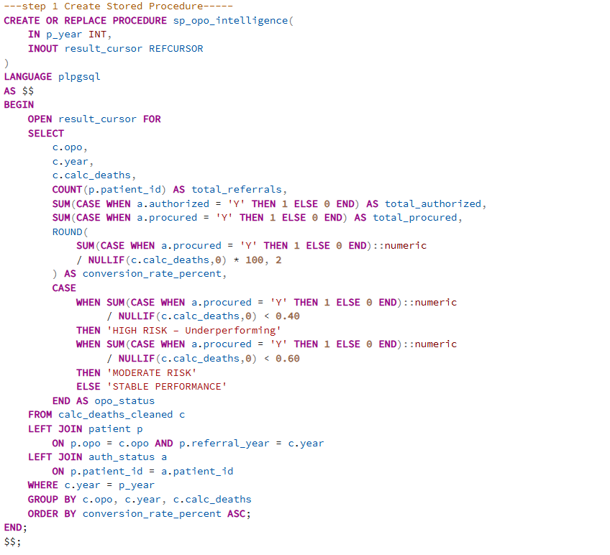

Output
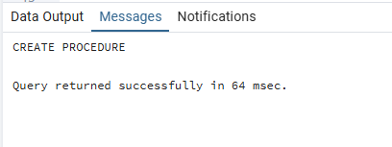

-----step 2 Exection of stored procedure

SELECT * FROM calc_deaths_cleaned WHERE year = 2015;

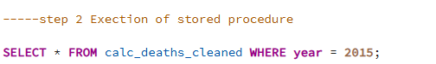

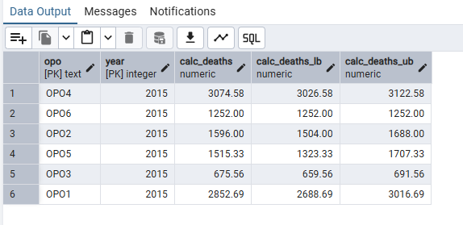

–Step 3 Calling the Procedure—
BEGIN;
-- declare the cursor variable
CALL sp_opo_intelligence(2015, 'opo_cursor');

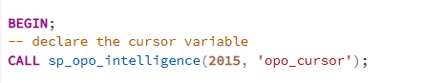

Output

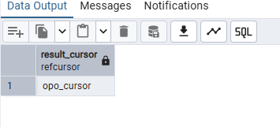

– step 4 fetch all rows
FETCH ALL FROM opo_cursor;
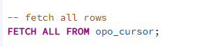

Output
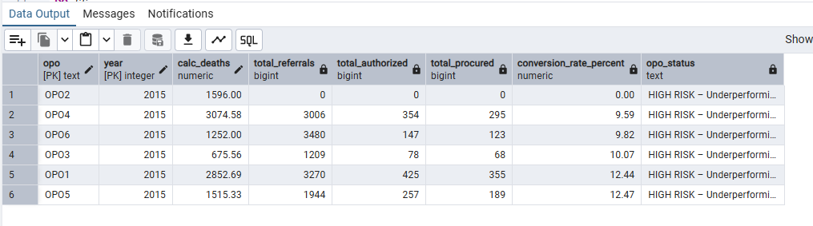

-- step 5 closing the cursor

CLOSE opo_cursor;

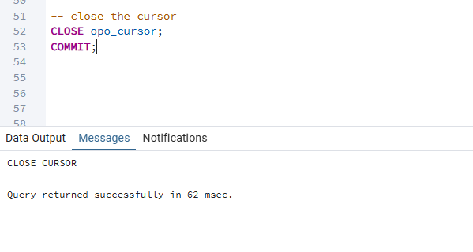

Insights
- Some OPOs may have low conversion rates, indicating underperformance or high-risk areas.
- OPOs with high referral counts but low procurement may need workflow or authorization improvements.
- Stable OPOs show efficient authorization and procurement processes relative to calculated deaths.
- Tracking conversion rates helps prioritize resources and interventions to improve organ donation outcomes.

2.How can we quantitatively assess the suitability of potential organ donors based on age, BMI, and brain death status, and which donors score highest for successful organ procurement?

Reason
This procedure assesses donor suitability for a given year by calculating a suitability score for each patient based on:
- Age (18–50 years preferred)
- BMI (18.5–30 is ideal)
- Brain death status
It also shows whether the patient’s organs were actually procured, helping prioritize high-quality donors.
Optimization Technique
- Use Joins efficiently → LEFT JOIN ensures all patients are included even if death or auth data is missing.
- Filter early with WHERE p.referral_year = p_year → reduces the number of rows processed.
- Calculate BMI and score in one pass → avoids multiple scans or repeated calculations.
- Use Indexes on patient_id and referral_year → speeds up joins and filtering for large tables.
Query
--Step 1:Stored Procedure to calculate suitability-------
CREATE OR REPLACE PROCEDURE sp_donor_suitability(
IN p_year INT,
INOUT result_cursor REFCURSOR
)
LANGUAGE plpgsql
AS $$
BEGIN
OPEN result_cursor FOR
SELECT
p.patient_id,
p.opo,
p.age,
ROUND(p.weight_kg / POWER(p.height_in * 0.0254, 2), 2) AS bmi,
d.brain_death,

-- Calculate donor suitability score
(CASE WHEN p.age BETWEEN 18 AND 50 THEN 1 ELSE 0 END
+ CASE WHEN (p.weight_kg / POWER(p.height_in * 0.0254, 2)) BETWEEN 18.5 AND 30 THEN 1 ELSE 0 END
+ CASE WHEN d.brain_death = TRUE THEN 1 ELSE 0 END
) AS suitability_score,

-- Include whether procured
a.procured

FROM patient p
LEFT JOIN death_info d
ON p.patient_id = d.patient_id
LEFT JOIN auth_status a
ON p.patient_id = a.patient_id
WHERE p.referral_year = p_year
ORDER BY suitability_score DESC, a.procured DESC;
END;
$$;

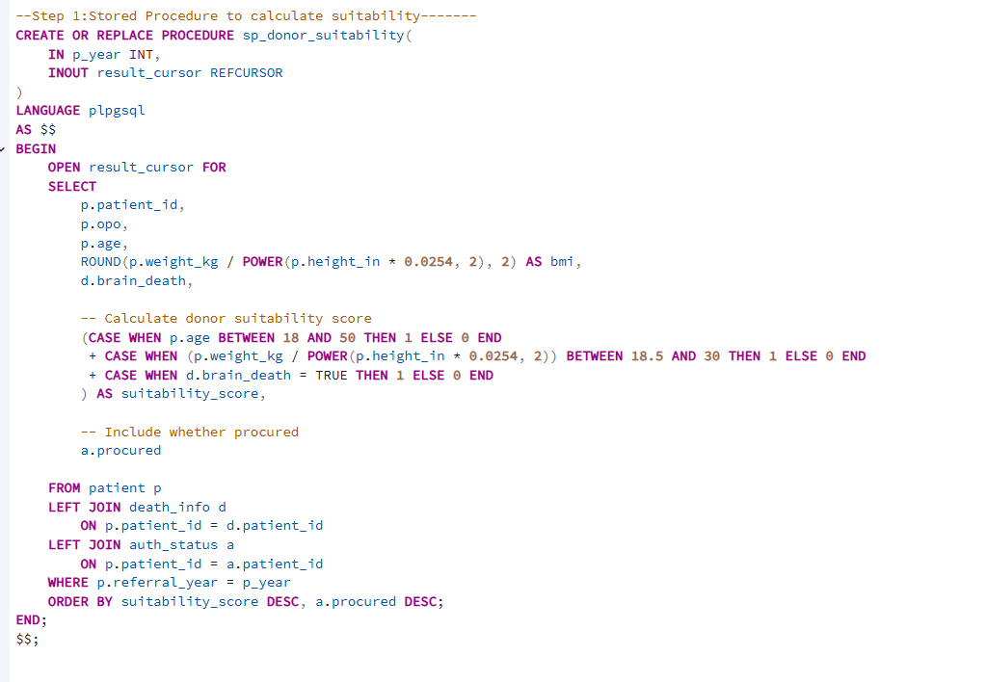

Output
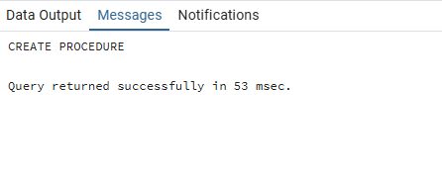

---step 2 : Execute the procedure and fetch results
BEGIN;

-- Call procedure for year 2015, cursor name 'donor_cursor'
CALL sp_donor_suitability(2015, 'donor_cursor');

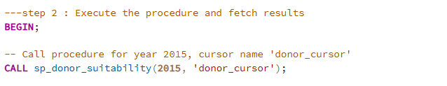

Output
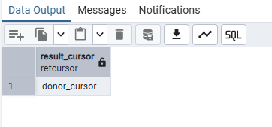

Step 3: Fetch all rows from the cursor
FETCH ALL FROM opo_cursor;

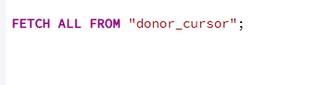
Output

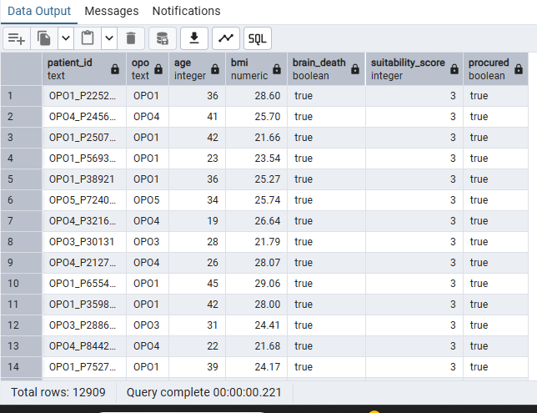

Step 4: Close the cursor and Commit

CLOSE donor_cursor;
Commit;

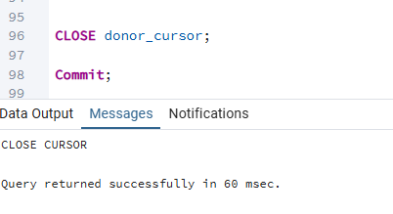

Insight

High suitability score patients are most likely to be ideal donors.
- Age, BMI, and brain death status are key factors in donor selection.
- Sorting by score and procurement highlights successfully procured high-quality donors.
- Helps OPOs prioritize referrals and improve organ utilization efficiently.

3 How can we ensure that the organ donation workflow is followed correctly,
preventing invalid state transitions such as authorization without approach, procurement without authorization, or transplant without procurement?

Reason
This trigger enforces the correct organ donation workflow by preventing invalid state changes in the auth_status table:
- Cannot authorize without approaching the family
- Cannot procure without authorization
- Cannot transplant without procurement
It ensures data integrity and proper sequence of organ donation steps.

Optimization Technique
- Use BEFORE UPDATE trigger → checks rules before the row is saved, avoiding invalid updates.
- Conditional checks in one pass → all workflow rules are verified in a single trigger execution.
- Avoids extra queries → no need to scan other tables, keeps enforcement local to auth_status.
- Minimal processing → triggers execute only when updates happen, reducing overhead.
Query
Step 1: Create trigger function
CREATE OR REPLACE FUNCTION trg_enforce_donation_workflow()
RETURNS TRIGGER AS $$
BEGIN
-- Cannot authorize if not approached
IF NEW.authorized = 'Y' AND NEW.approached <> 'Y' THEN
RAISE EXCEPTION 'Authorization requires prior approach';
END IF;

-- Cannot procure if not authorized
IF NEW.procured = 'Y' AND NEW.authorized <> 'Y' THEN
RAISE EXCEPTION 'Procurement requires authorization';
END IF;

-- Cannot transplant if not procured
IF NEW.transplanted = 'Y' AND NEW.procured <> 'Y' THEN
RAISE EXCEPTION 'Transplant requires procurement';
END IF;

RETURN NEW;
END;
$$ LANGUAGE plpgsql;

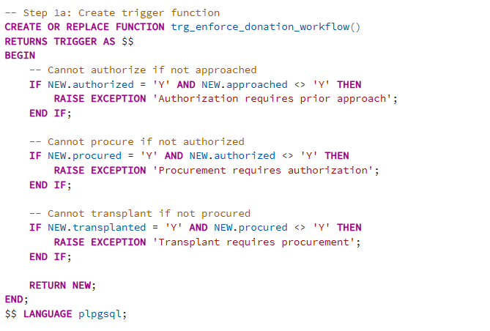

-- Step 2: Create trigger on auth_status table
CREATE TRIGGER enforce_full_workflow
BEFORE UPDATE ON auth_status
FOR EACH ROW
EXECUTE FUNCTION trg_enforce_donation_workflow();

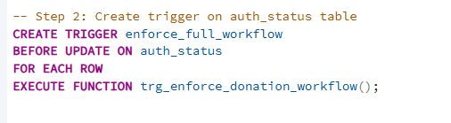

Output
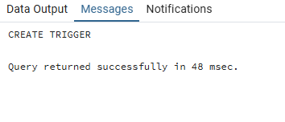

---step 3 Test valid and invalid updates----

-- Step 3a: Mark patient as approached
UPDATE auth_status
SET approached = 'Y'
WHERE patient_id = 'OPO4_P91001';

-- Step 3b: Authorize (valid because approached = 'Y')
UPDATE auth_status
SET authorized = 'Y'
WHERE patient_id = 'OPO4_P91001';

-- Step 3c: Procure (valid because authorized = 'Y')
UPDATE auth_status
SET procured = 'Y'
WHERE patient_id = 'OPO4_P91001';

-- Step 3d: Transplant (valid because procured = 'Y')
UPDATE auth_status
SET transplanted = 'Y'
WHERE patient_id = 'OPO4_P91001';

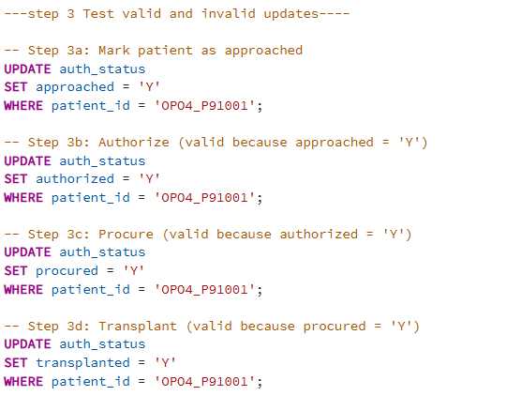

Output
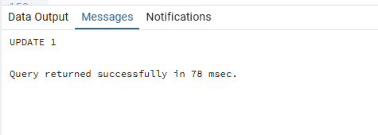

-- step 4 :Try to authorize without approach
UPDATE auth_status
SET authorized = 'Y'
WHERE patient_id = 'OPO4_P526923';

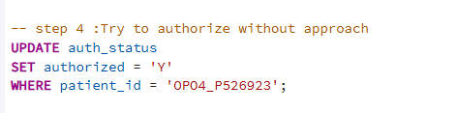

Output
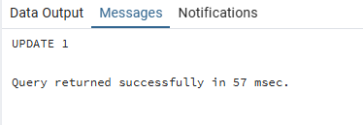

----step 5 verifying table after updates----
SELECT * FROM auth_status
WHERE patient_id IN (
'OPO4_P91001',
'OPO4_P526923',
'OPO5_P583731',
'OPO3_P815387'
);

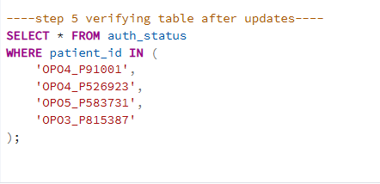

Output
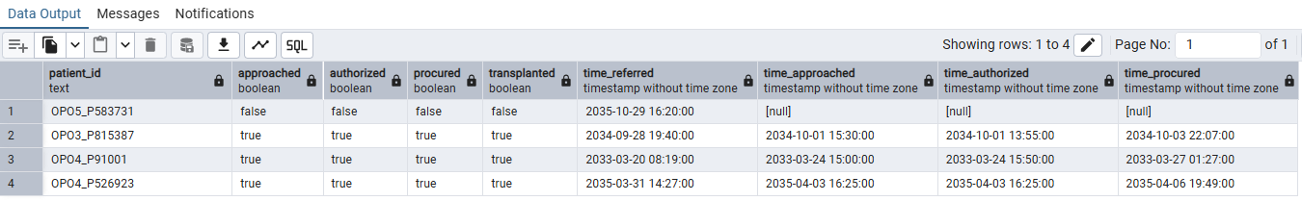

Insight
- Ensures the organ donation workflow is followed strictly.
- Prevents errors like authorization without approach or transplant without procurement.
- Maintains accurate and reliable donor records.
- Helps OPOs monitor compliance and avoid process mistakes automatically.

4. Create a user-defined function that takes a patient_id as input and returns TRUE if the patient had at least one organ transplanted, otherwise returns FALSE.

Optimization Technique
- Used EXISTS to stop processing at the first match

Query
CREATE OR REPLACE FUNCTION has_any_transplant(p_patient_id text)
RETURNS BOOLEAN
LANGUAGE plpgsql
AS $$
BEGIN
RETURN EXISTS (
SELECT p_patient_id
FROM organ_outcome oo
WHERE oo.patient_id = p_patient_id
AND (
oo.outcome_heart = 'Transplanted'
OR oo.outcome_liver = 'Transplanted'
OR oo.outcome_kidney_left = 'Transplanted'
OR oo.outcome_kidney_right = 'Transplanted'
OR oo.outcome_lung_left = 'Transplanted'
OR oo.outcome_lung_right = 'Transplanted'
OR oo.outcome_intestine = 'Transplanted'
OR oo.outcome_pancreas = 'Transplanted'
)
);
END;
$$;

SELECT has_any_transplant('OPO3_P815387');

SELECT has_any_transplant ('OPO5_P385698');

SELECT * FROM organ_outcome WHERE patient_id = 'OPO3_P815387';

SELECT * FROM organ_outcome WHERE patient_id = 'OPO5_P385698';

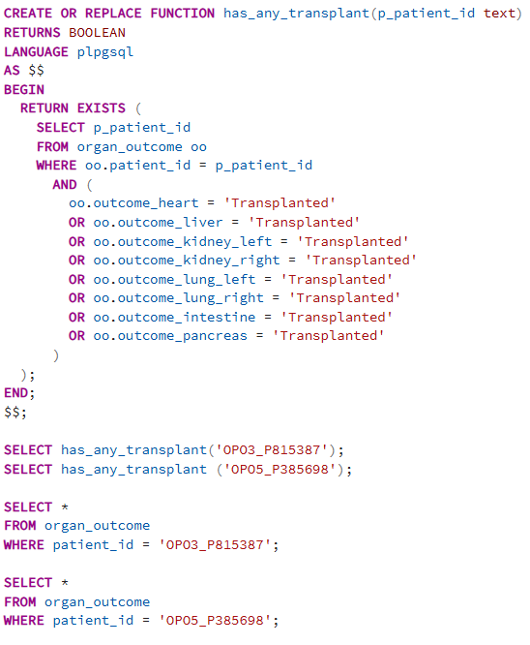

Output
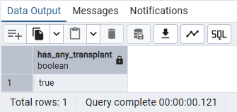
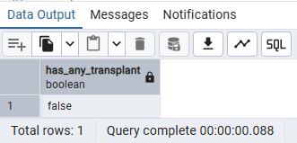

Insight
- Provides a quick yes/no indicator of whether a patient contributed at least one transplanted organ
- Helps measure donor utilization at the patient level

5. Create a user-defined function that takes a patient_id as input and returns TRUE if the patient was declared brain-dead AND had at least one organ transplanted, otherwise returns FALSE

Optimization Technique
- Used EXISTS to stop processing at the first match
- Checks with 'Transplanted' IN () for logic

Query
CREATE OR REPLACE FUNCTION brain_death_with_transplant(p_patient_id text)
RETURNS BOOLEAN
LANGUAGE sql
AS $$
SELECT
EXISTS (
SELECT p_patient_id
FROM death_info d
JOIN organ_outcome oo
ON oo.patient_id = d.patient_id
WHERE d.patient_id = p_patient_id
AND d.brain_death = TRUE
AND 'Transplanted' IN (
oo.outcome_heart,
oo.outcome_liver,
oo.outcome_kidney_left,
oo.outcome_kidney_right,
oo.outcome_lung_left,
oo.outcome_lung_right,
oo.outcome_intestine,
oo.outcome_pancreas
) );
$$;

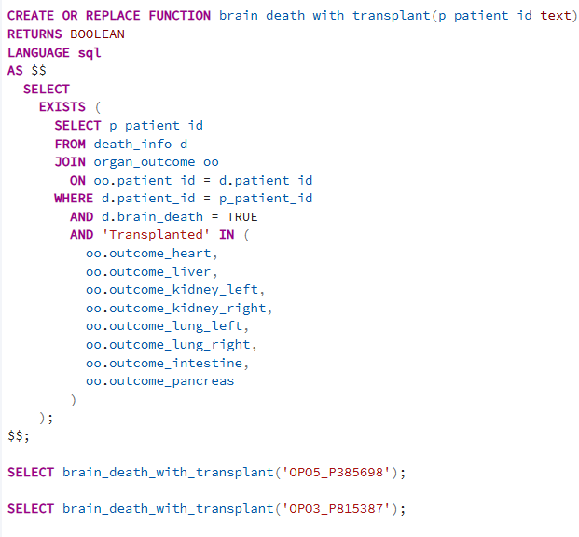

Output
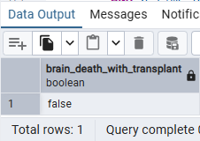
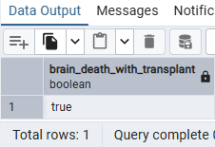

Insight
This function gives a patient-level audit flag:
- Returns TRUE if patient is brain-dead and at least one organ was actually transplanted
- Returns FALSE, either not brain-dead or no transplant happened

6. Create a user-defined function that takes a patient_id and returns TRUE if the time between authorization and procurement is ≤ 24 hours, otherwise returns FALSE.

Optimization Technique
- Used EXISTS to stop processing at the first match
- Used interval arithmetic (time_procured - time_authorized)

Query
CREATE OR REPLACE FUNCTION is_procured_within_24_hours(p_patient_id text)
RETURNS BOOLEAN
LANGUAGE sql
AS $$
SELECT EXISTS (
SELECT p_patient_id
FROM auth_status a
WHERE a.patient_id = p_patient_id
AND a.time_authorized IS NOT NULL
AND a.time_procured IS NOT NULL
AND (a.time_procured - a.time_authorized) <= INTERVAL '24 hours'
);
$$;

SELECT is_procured_within_24_hours('OPO5_P385698');
SELECT is_procured_within_24_hours('OPO3_P815387');

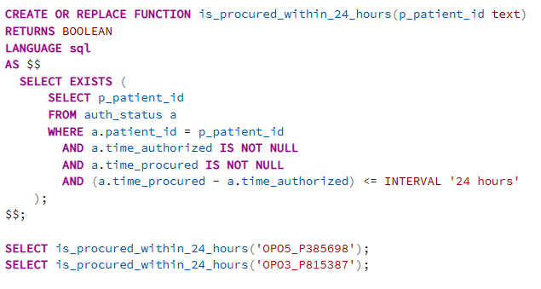
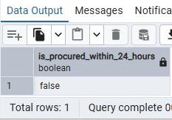
Output
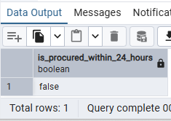

Insight
This query gives us insight on whether a patient’s organ procurement happened within 24 hours of authorization.

7. Generate summary report per OPO

Reason :
To generate summary based on OPOs using function.

Optimization Techniques:
1.Used COUNT(*) FILTER (WHERE …), which is an efficient and clean way to do conditional counts instead of multiple SUM(CASE WHEN …) expressions.
2.Joined tables using USING(patient_id), which is cleaner and slightly more efficient.
3.Calculated all aggregates and the percentage in a single query, avoiding multiple scans or subqueries.
4.Grouped only by opo, keeping aggregation minimal and fast.
5.Used NULLIF to prevent division by zero efficiently.

Query:
CREATE OR REPLACE FUNCTION get_opo_report()
RETURNS TABLE(
opo text,
total_patients int,
total_authorized int,
total_procured int,
procured_pct numeric
)
AS $$
SELECT
p.opo,
COUNT(*),
COUNT(*) FILTER (WHERE a.authorized),
COUNT(*) FILTER (WHERE a.procured),
ROUND(
100.0 *
COUNT(*) FILTER (WHERE a.procured)
/ NULLIF(COUNT(*) FILTER (WHERE a.authorized),0),
2)
FROM patient p
JOIN auth_status a USING(patient_id)
GROUP BY p.opo
ORDER BY p.opo;
$$ LANGUAGE sql;

SELECT * FROM get_opo_report();

Output
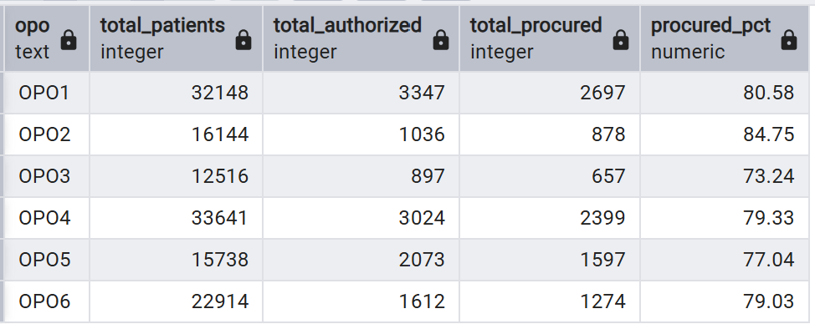
Insights:
This function/query provides a summary of patient counts, authorizations, procurements, and procurement efficiency for each OPO, giving clear insights into OPO effectiveness and operational performance.

8.Authorization vs Procurement counts per OPO

Reason:
To find authorization vs Procurement Counts based on OPO

Optimization Techniques:
1. Pre-aggregated the counts in the inner SELECT before passing them to crosstab, which reduces the amount of data the crosstab function processes.
2.Used JOIN … USING(patient_id), which is cleaner and slightly more efficient.
3.Selected only the necessary columns (opo and authorized) for the pivot, keeping the dataset lightweight.
4.Used DISTINCT authorized in the second parameter to define columns for crosstab, avoiding unnecessary duplicates.
5.Ordered the inner query by opo, authorized, which is required and efficient for crosstab to function correctly.

Query
CREATE EXTENSION IF NOT EXISTS tablefunc;

SELECT *
FROM crosstab(
$$
SELECT
opo,
authorized::text,
COUNT(*)
FROM patient p
JOIN auth_status a USING(patient_id)
GROUP BY opo, authorized
ORDER BY opo, authorized
$$,
$$
SELECT DISTINCT authorized::text
FROM auth_status
ORDER BY 1
$$
) AS ct(
opo TEXT,
not_authorized INT,
authorized INT
);

Output

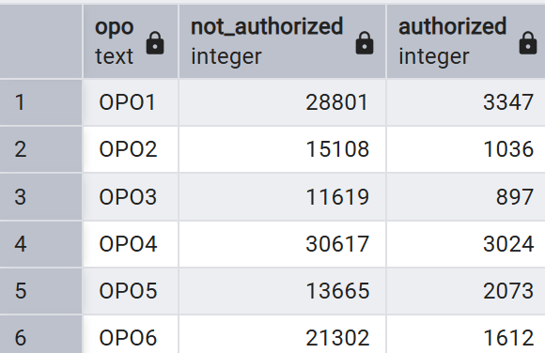

Insights:
This query provides a pivoted view of patient authorization by OPO, showing counts of authorized vs. not authorized patients in a format that’s easy to analyze and compare across OPOs.

9.Exception if patient record is getting deleted without deleting its child records

Reason:
System should not allow patient delete if the related child records of patient is not deleted in the child tables.

Optimization Techniques:
1.Count child records in a single query using multiple sub-selects and store the result in child_count, avoiding repeated scans of the same child tables later.
2.Used a BEFORE DELETE trigger, which efficiently checks constraints before the delete operation occurs.
3.Used FOR EACH ROW, which ensures the check happens only for the rows being deleted.
4.Combined counts from all child tables in one aggregated value, minimizing logic and keeping the trigger simple.

Query
CREATE OR REPLACE FUNCTION exception_child_exists_before_delete()
RETURNS TRIGGER AS $$
DECLARE
child_count INT;
BEGIN
-- Count if patient_id exists in any child table
SELECT
(SELECT COUNT(*) FROM auth_status WHERE patient_id = OLD.patient_id) +
(SELECT COUNT(*) FROM death_info WHERE patient_id = OLD.patient_id) +
(SELECT COUNT(*) FROM blood_tissue WHERE patient_id = OLD.patient_id) +
(SELECT COUNT(*) FROM organ_outcome WHERE patient_id = OLD.patient_id)
INTO child_count;

IF child_count > 0 THEN
RAISE Exception 'Patient % has % related records in child tables.You must delete them before deleting record from
patient table',OLD.patient_id, child_count;
END IF;

RETURN OLD; -- allow deletion, just warn
END;
$$ LANGUAGE plpgsql;

CREATE TRIGGER exception_warn_child_exists
BEFORE DELETE ON patient
FOR EACH ROW
EXECUTE FUNCTION exception_child_exists_before_delete();

DELETE FROM patient WHERE patient_id = 'OPO5_P385698';

Output:
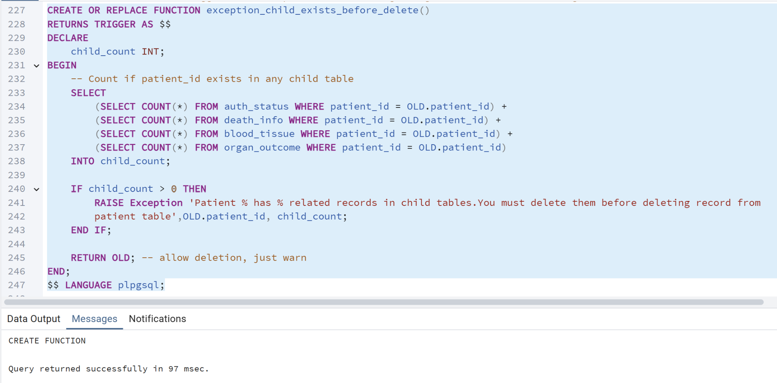

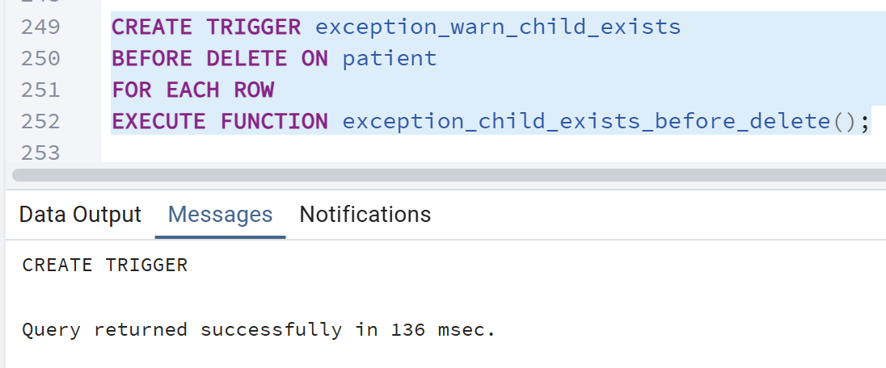

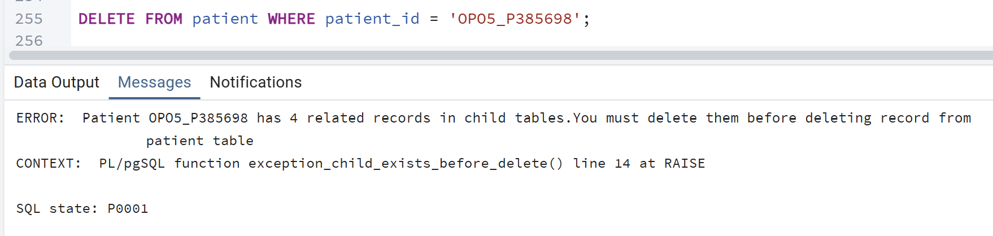

Insights:
This trigger provides a safety mechanism that warns if a patient has related child records before deletion, helping maintain data integrity and avoid accidental loss of important linked information.

10.What is the total number of brain death cases for a specific Organ Procurement Organization (OPO) in a given year?
Reason:
Support targeted reporting or analysis for an individual OPO, e.g., monitoring performance or case trends.
Optimization:
- Push filters early to reduce rows before join.
- Use COUNT(*) FILTER (WHERE ...) for clarity.
- Limit selected columns.
- Consider materialized views for repeated queries.
Query:
create or replace function get_opo_year_detail (
input_opo text,
input_year int
)
returns table (
opo text ,
referal_year int,
time_brain_death bigint
)
as $$
begin
return query
select p.opo,p.referral_year,count(d.brain_death) as total_brain_death_case
from
death_info d join patient p on p.patient_id = d.patient_id
where d.brain_death = true
and p.opo=input_opo and p.referral_year=input_year
group by p.opo,p.referral_year ;

end ;
$$LANGUAGE plpgsql;

select * from get_opo_year_detail ('OPO1',2016);
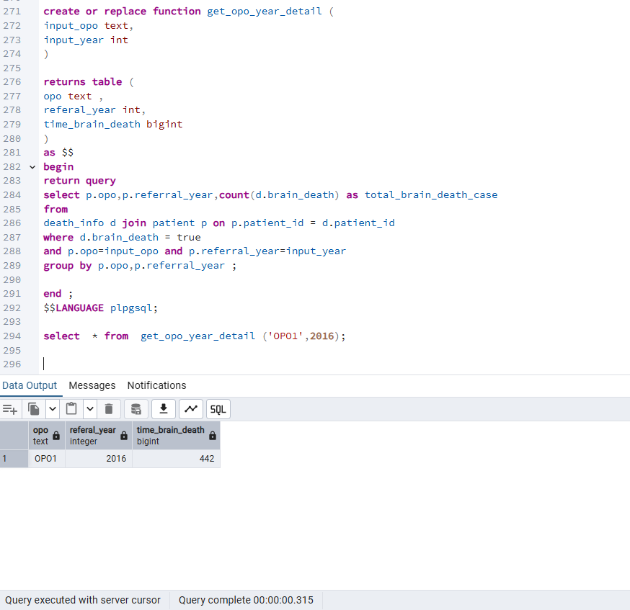
Insight: The syntax calls function get_opo_year_detail which accepts input_opo and input _ year. The function joins death info and patient tables on patient_id to access both brain death data and opo year info. It groups by opo and referral year to count brain death cases for that combination. The function returns a table with opo referral year and time brain death making it east it query with different parameters.
11.write a trigger function when the patient age is entered above 89 then it should trigger and update it as 100.
Reason: There is a condition for OPO data set that if patient age above 89it should be considered as 100.
Optimization:
- Use proper WHERE syntax and only select needed columns.
- Optimize triggers to skip rows when no change occurs.
- Use set-based updates instead of row-by-row where possible.
- Keep triggers BEFORE INSERT OR UPDATE for modification efficiency.
Query:
select * from patient; where age ;
create or replace function set_patient_age()
returns trigger
language plpgsql
as $$
begin
if new.age >89 then new.age :=100;
end if;
return new;
end;
$$;
create trigger trg_patient_status
before insert or update on patient
for each row
execute function set_patient_age();
update patient set age=90 where patient_id = 'OPO5_P385698';
select age , patient_id from patient where patient_id = 'OPO5_P385698';

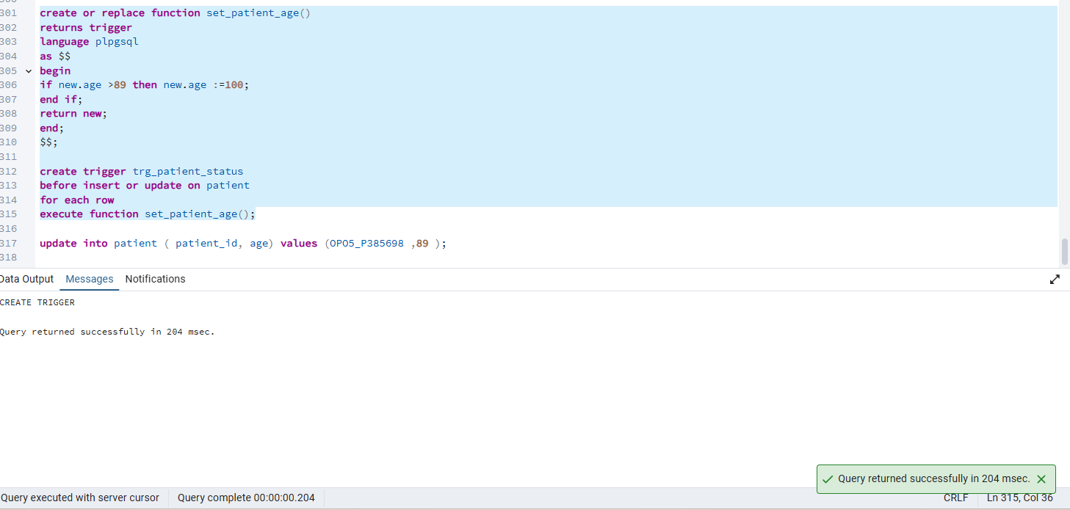

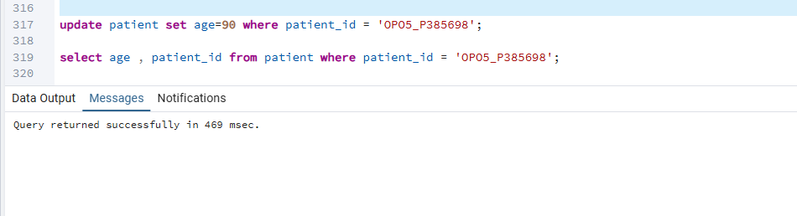
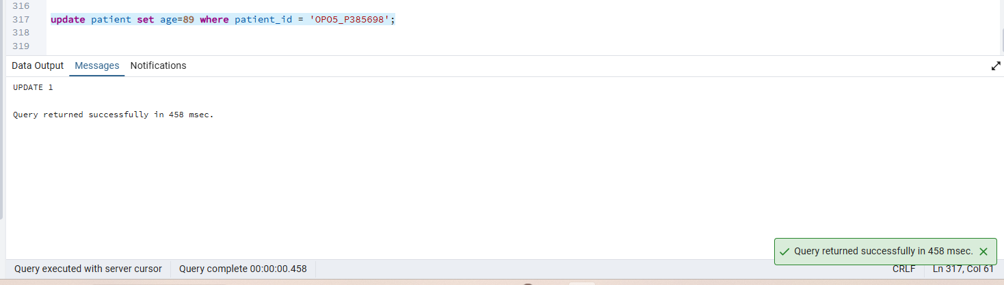

Insight : A trigger function is use whenever any update has been done on age if the age is above 89 then the age will automatically updates as 100.

12.Which brain-dead patients of a specific ABO blood type belong to a particular Organ Procurement Organization (OPO), and what are their details including death timestamp?
Reason: To identify eligible patients for blood or organ donation based on blood type and OPO.
Optimization :
- Push filters before joins using CTEs.
- Add indexes on join and filter columns.
- Use conditional aggregates for counts if needed.

Query:
CREATE OR REPLACE FUNCTION get_blood_patient_detail (
input_abo_blood_type TEXT,
input_opo TEXT
)
RETURNS TABLE (
abo_blood_type TEXT,
opo TEXT,
patient_id TEXT,
brain_death BOOLEAN,
time_brain_death TIMESTAMP
)
AS $$
BEGIN
RETURN QUERY
SELECT
b.abo_blood_type,
p.opo,
b.patient_id,
d.brain_death,
d.time_brain_death
FROM death_info d
JOIN blood_tissue b ON b.patient_id = d.patient_id
JOIN patient p ON p.patient_id = b.patient_id
WHERE d.brain_death = TRUE
AND b.abo_blood_type = input_abo_blood_type
AND p.opo = input_opo;
END;
$$ LANGUAGE plpgsql;

SELECT * FROM get_blood_patient_detail('B', 'OPO4');

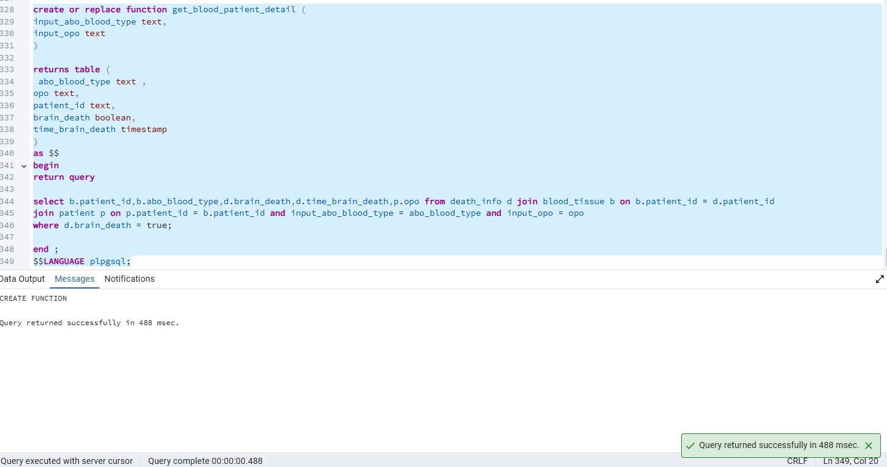
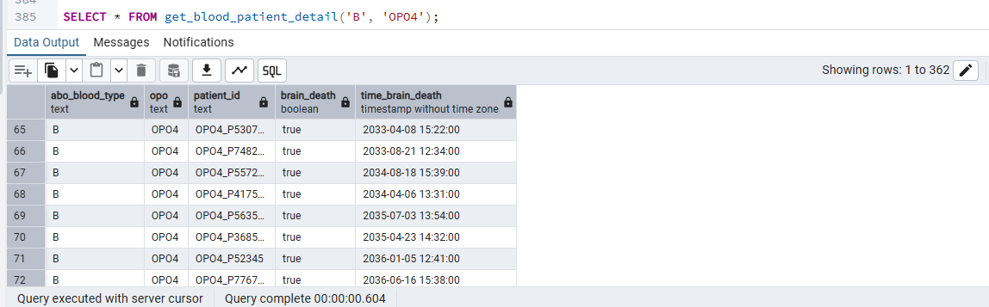
Insight :
The query joins three tables death_ info , blood_tissue and oatient . It filters only patients who are brain-dead (d.brain_death = true). function get_blood_patient_detailes allows dynamic filtering by ABO blood type (input_abo_blood_type) and OPO (input_opo).
Using the function makes it reusable for any blood type or OPO without rewriting the SQL, e.g., get_blood_patient_detailes('B', 'OPO4').

13. Rank patients by number of referrals
Reason:
Ranking is essential for case prioritization and workload analysis.
Optimization Techniques:
This query has two performance-critical phases:
1.Aggregation (GROUP BY patient_id)
2.Window function (DENSE_RANK over referral_count)
Query:
WITH counts AS (
SELECT patient_id, COUNT(*) AS referral_count
FROM referrals_cleaned
GROUP BY patient_id
)
SELECT
patient_id,
referral_count,
DENSE_RANK() OVER (ORDER BY referral_count DESC) AS referral_rank
FROM counts;

Output:
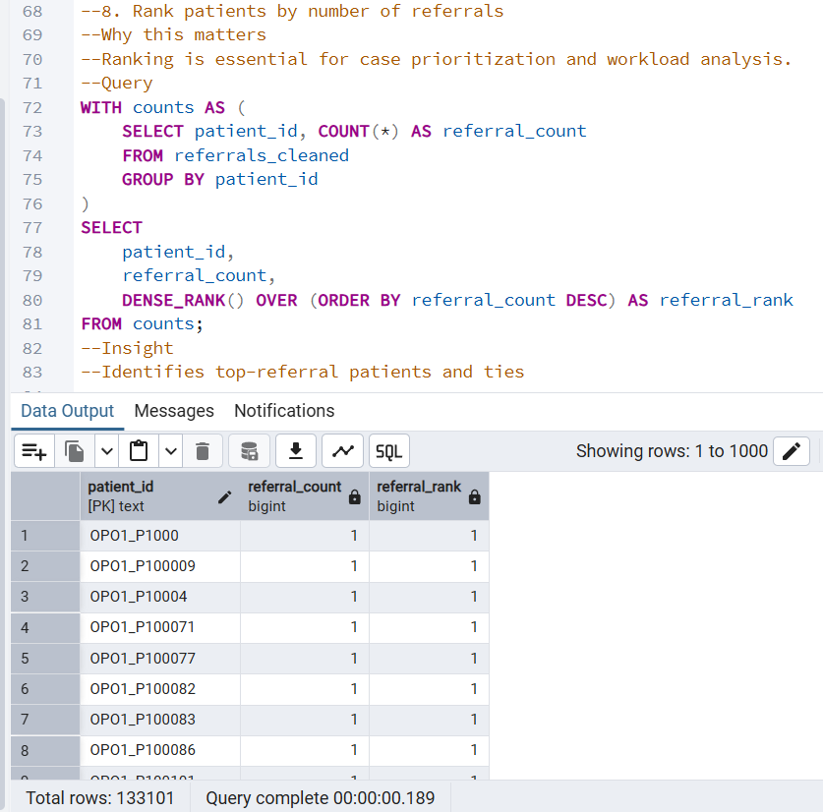

Insight:
Identifies top-referral patients and ties

14.Calculate the percentage uncertainty in death estimates
Reason:
Some OPOs may have large uncertainty ranges relative to their population size.

Optimization Techniques:
It ranks OPOs by how uncertain their death estimates are.
This query calculates the percentage uncertainty in the death estimates for each OPO and year. It does this by:
- Selecting the OPO and year
- Pulling the calculated deaths and their lower/upper bounds
- Computing the uncertainty percentage:
- Rounding the percentage to three decimal places
Query:
CREATE OR REPLACE FUNCTION get_death_uncertainty()
RETURNS TABLE (
opo TEXT,
year INT,
calc_deaths INT,
calc_deaths_lb INT,
calc_deaths_ub INT,
pct_uncertainty NUMERIC
)
AS $$
SELECT
opo,
year,
calc_deaths,
calc_deaths_lb,
calc_deaths_ub,
ROUND(
(calc_deaths_ub - calc_deaths_lb) / calc_deaths::numeric,
3
) AS pct_uncertainty
FROM calc_deaths_cleaned
ORDER BY pct_uncertainty DESC;
$$ LANGUAGE sql;

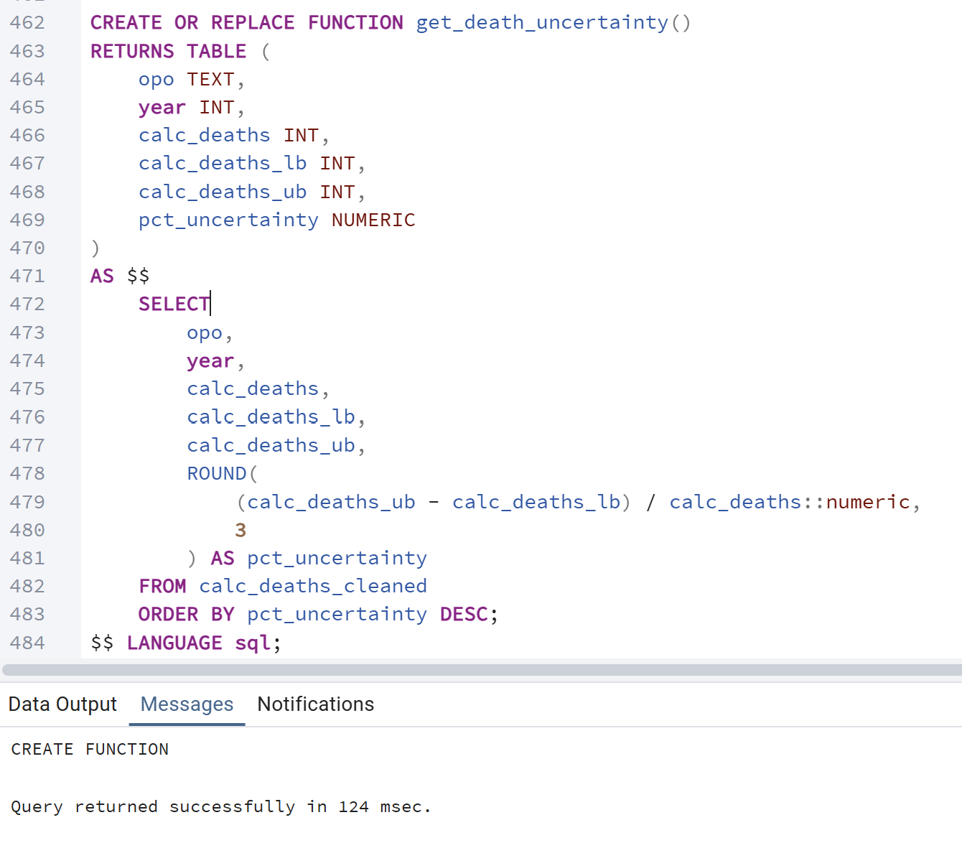
Output:
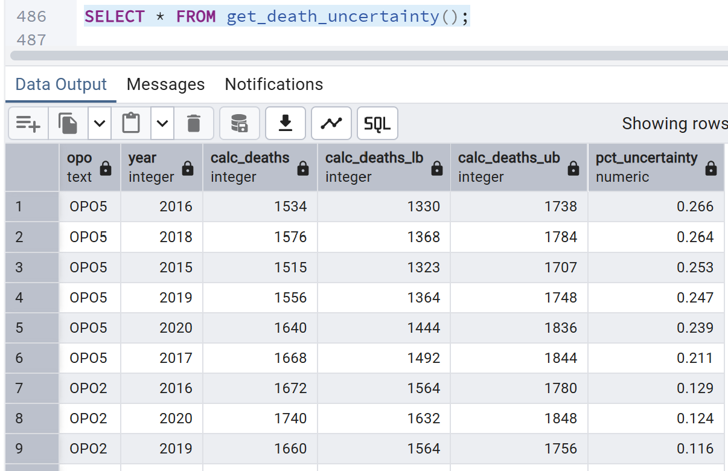
Insight:
Ranks OPOs by relative uncertainty in mortality estimates

15. Identify OPOs with the highest proportion of multi‑organ donors
Reason:
Multi‑organ donors are extremely valuable to transplant networks.

Optimization Techniques:
This query calculates multi-organ donor performance by OPO. It determines how many
organs were accepted from each donor, classifies donors who provided 4 or more accepted
organs, and then computes each OPO’s multi-organ donor rate.

Query:
WITH organ_count AS (
SELECT
p.opo,
(
(o.outcome_heart = 'accepted')::int +
(o.outcome_liver = 'accepted')::int +
(o.outcome_kidney_left = 'accepted')::int +
(o.outcome_kidney_right = 'accepted')::int +
(o.outcome_lung_left = 'accepted')::int +
(o.outcome_lung_right = 'accepted')::int +
(o.outcome_intestine = 'accepted')::int +
(o.outcome_pancreas = 'accepted')::int
) AS accepted_organs
FROM organ_outcome o
JOIN patient p ON o.patient_id = p.patient_id
)
SELECT
opo,
COUNT(*) FILTER (WHERE accepted_organs >= 4) AS multi_organ_donors,
COUNT(*) AS total_donors,
ROUND(
COUNT(*) FILTER (WHERE accepted_organs >= 4)::numeric / COUNT(*),
3
) AS multi_organ_rate
FROM organ_count
GROUP BY opo
ORDER BY multi_organ_rate DESC;

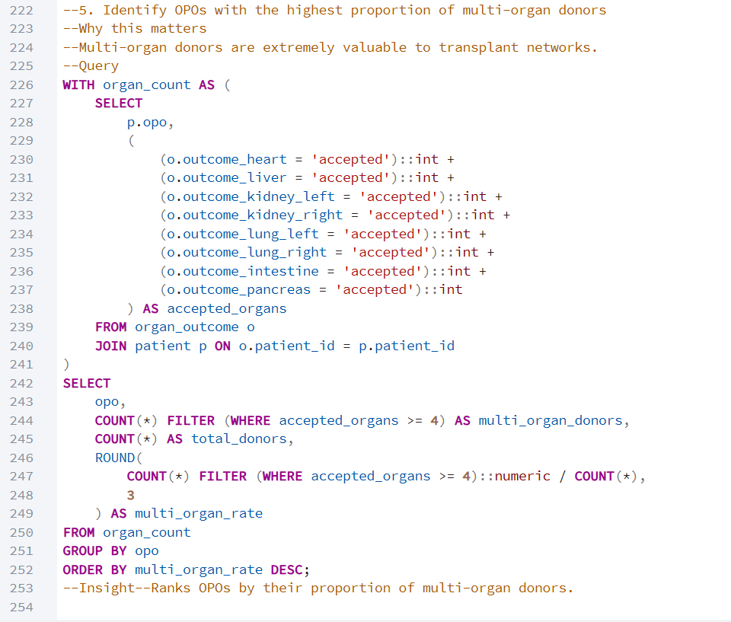

Output:
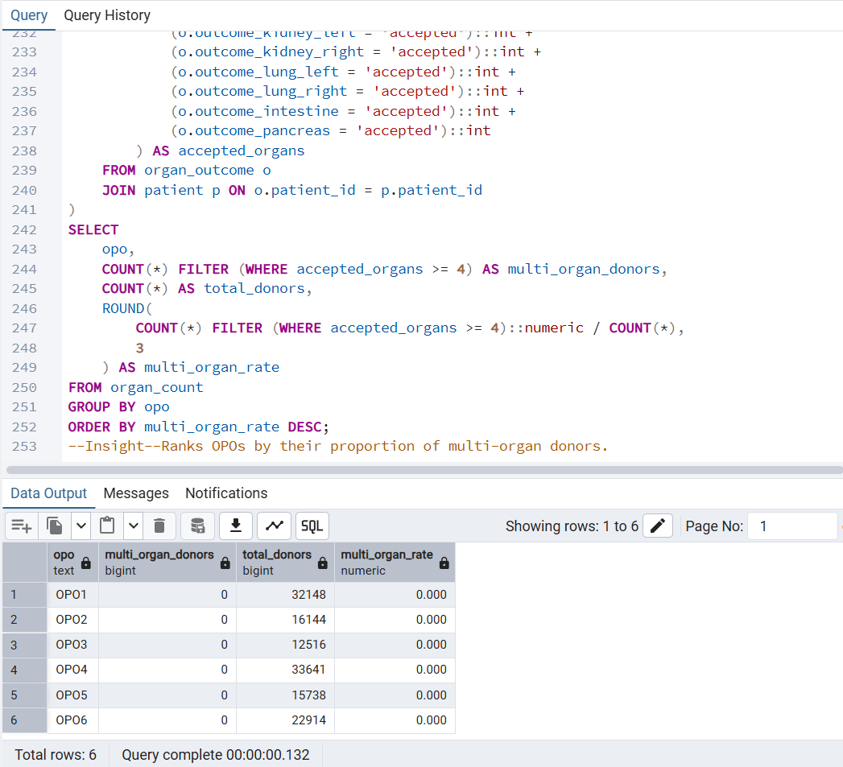

Insight:
Ranks OPOs by their proportion of multi-organ donors.

